**EXP 1**

**Coding**

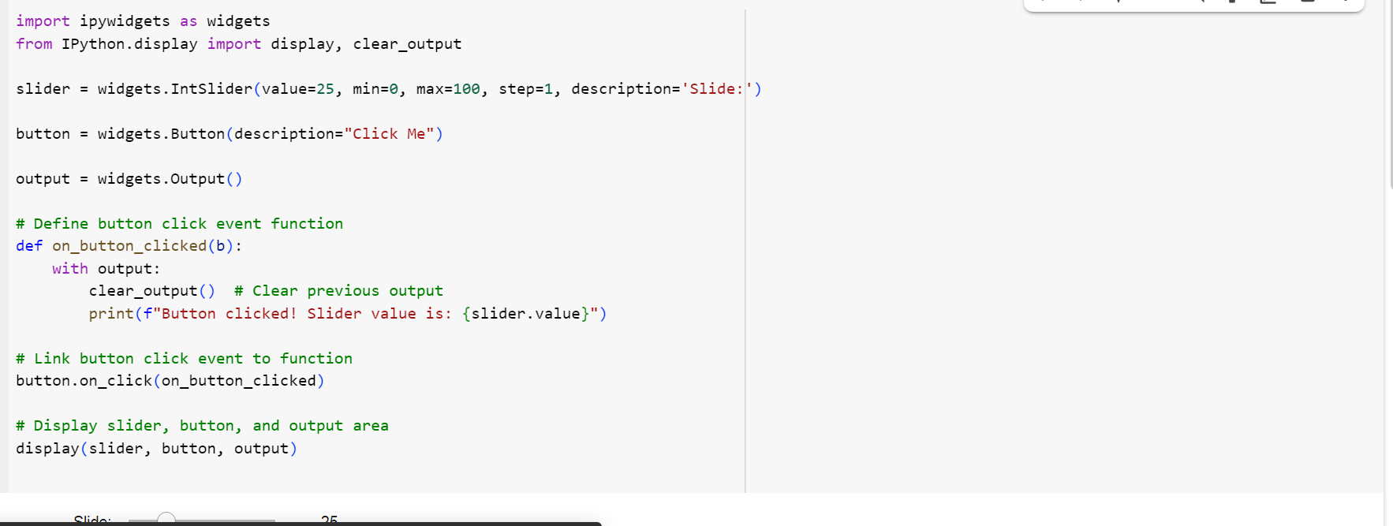

**Output**

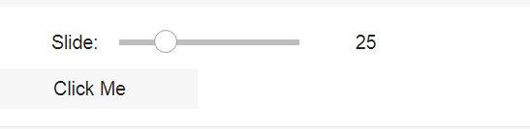

EXP 2

**Coding**

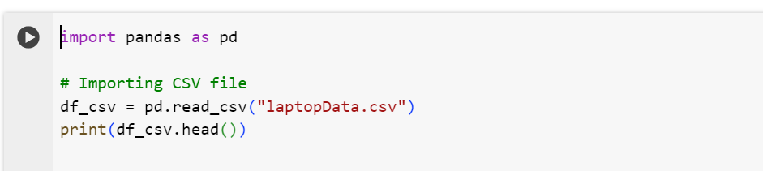

**Output**

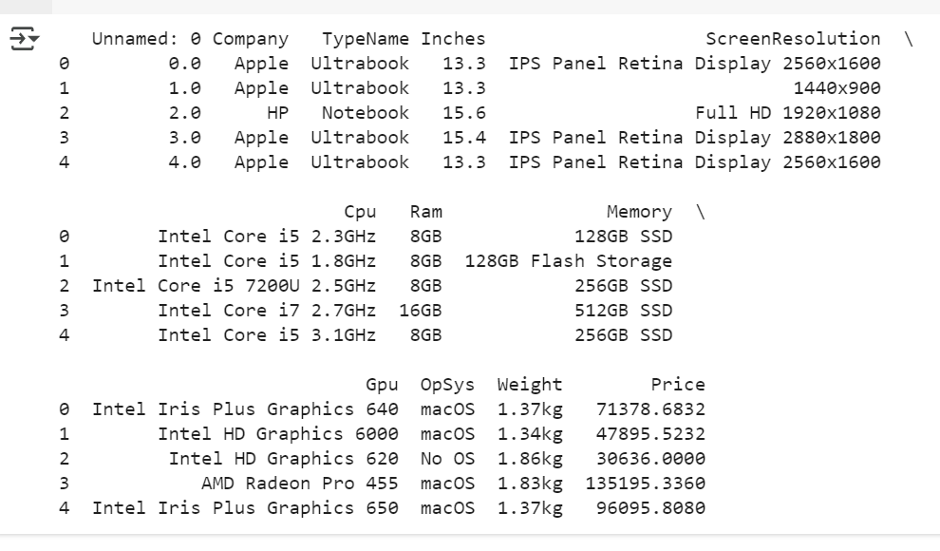

**Coding**

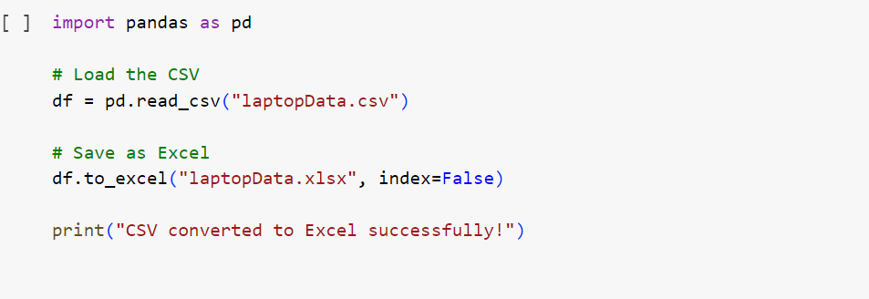

**Output**



**Coding**

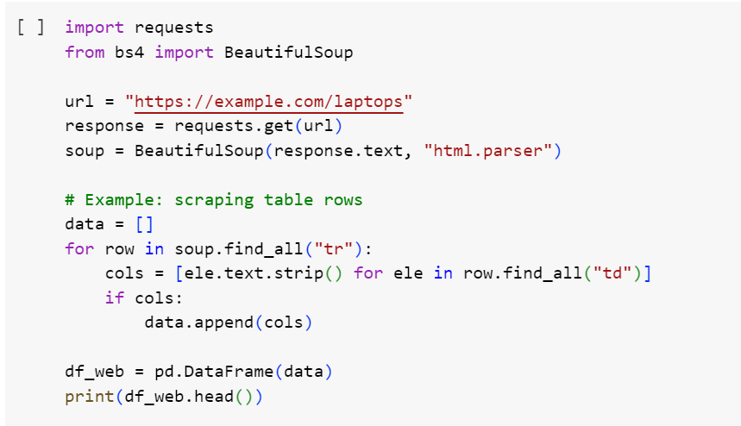

**Output**



EXP 3

EDA-Data Cleaning

Handling missing values: detection, filling, and dropping

Removing duplicates and unnecessary data

Data type conversion and ensuring consistency

Normalize data (e.g., standardization, min-max scaling)

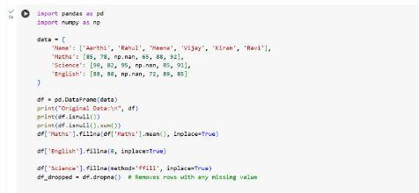

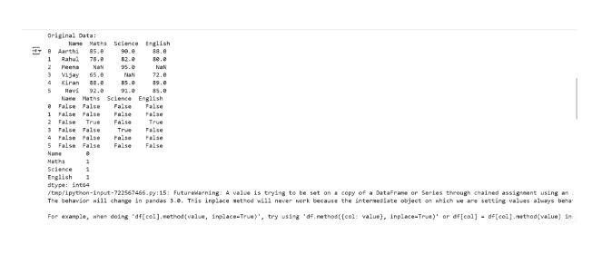

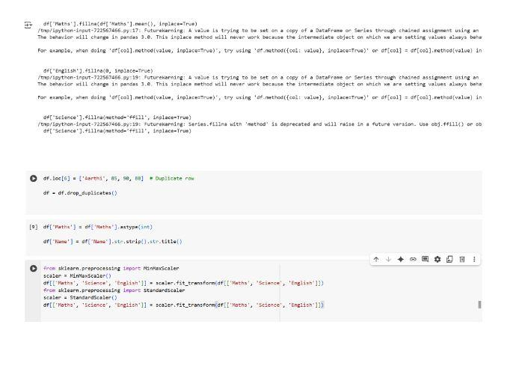

# EXP 4

EDA-Data Inspection and Analysis

Viewing and inspecting DataFrames

Filtering and subsetting data using conditions

Descriptive statistics: measures of central tendency (mean, median, mode) and measures of

dispersion (range, variance, standard deviation)

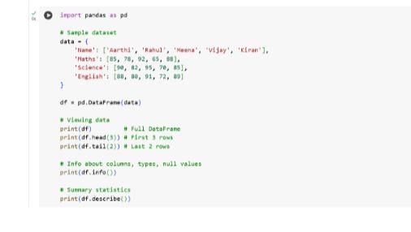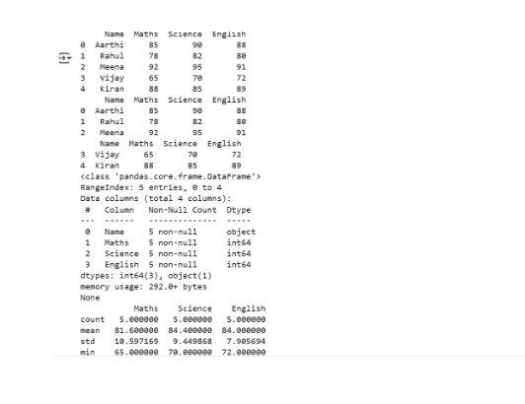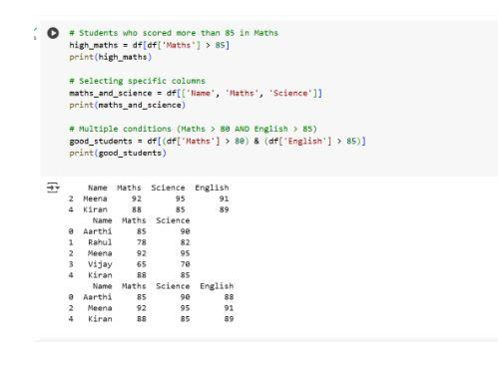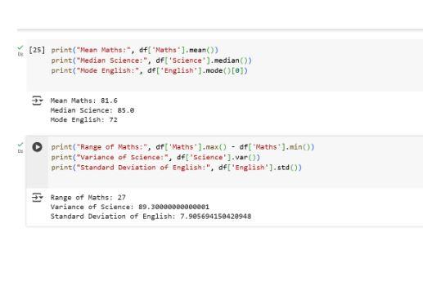

EXP 5

EDA-Data Visualization with Matplotlib

Basic plotting: line charts, bar charts, histograms

line charts:

CODE:

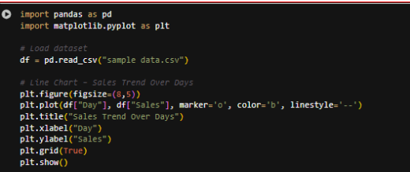

OUTPUT

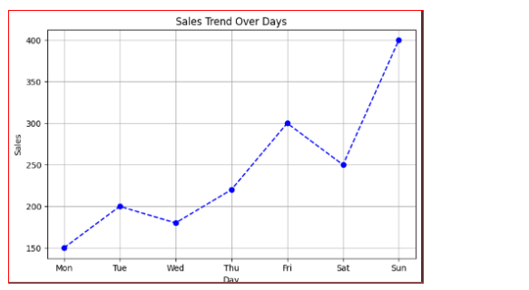

Bar charts:

CODE:

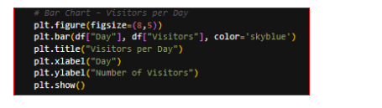

OUTPUT: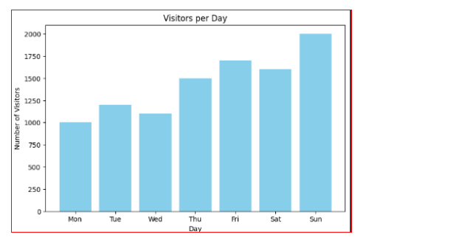

Histograms:

CODE:

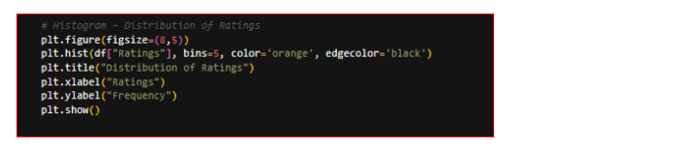

OUTPUT:

